Data Preparation/Feature Engineering
Project Title: Forecasting Disease Outbreaks Using Integrated Mobility and Health Data
Team Members
- Han D D Htet
- Kyaw Zin Htet
- Aung Ko Min
- Naing Lin

1. Overview
This phase consolidated health/policy and mobility time-series for Japan into a single, analysis-ready dataset, performed rigorous cleaning, explored temporal and cross-feature relationships, and engineered features suitable for downstream time-series modeling (LSTM). The goal was to ensure high-quality inputs, capture lagged/seasonal dynamics, and surface drivers of COVID-19 trends prior to model training.

2. Data Collection
- Sources:
  - Health/Policy: Our World in Data (OWID) COVID dataset fields for Japan: new_cases, new_deaths, hosp_patients, positive_rate, stringency_index.
  - Mobility: Google Community Mobility Reports for Japan (country level, sub_region_1 is null), using percent change from baseline for: retail, grocery/pharmacy, parks, transit stations, workplaces, residential.
- Merging:
  - Datasets were merged on date with an inner join to align observations.
- Export:
  - Final master dataset saved to data/japan_covid_master_data.csv.

3. Data Cleaning
- Datetime normalization: `date` parsed to datetime and set as index for time-series operations.
- Missing values:
  - Forward-fill applied to slowly-varying indicators: `hosp_patients`, `positive_rate`, `stringency_index`, and mobility features.
  - `new_cases`, `new_deaths` missing values set to 0.
- Duplicates and integrity:
  - EDA confirmed duplicate count; summaries inspected for anomalies.
- Output:
  - Cleaned master saved at `data/japan_covid_master_data.csv` with schema: `date,new_cases,new_deaths,hosp_patients,positive_rate,stringency_index,[mobility columns...]`.

4. Exploratory Data Analysis (EDA)
- Time-series trends: Multi-panel views for new_cases, new_deaths, hosp_patients, positive_rate show waves and policy/behavioral shifts.
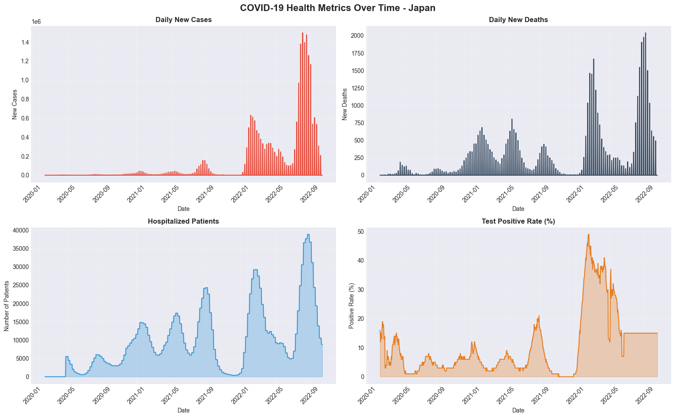

- Mobility: Trends for retail, workplace, transit, residential vs. baseline with zero-line reference.
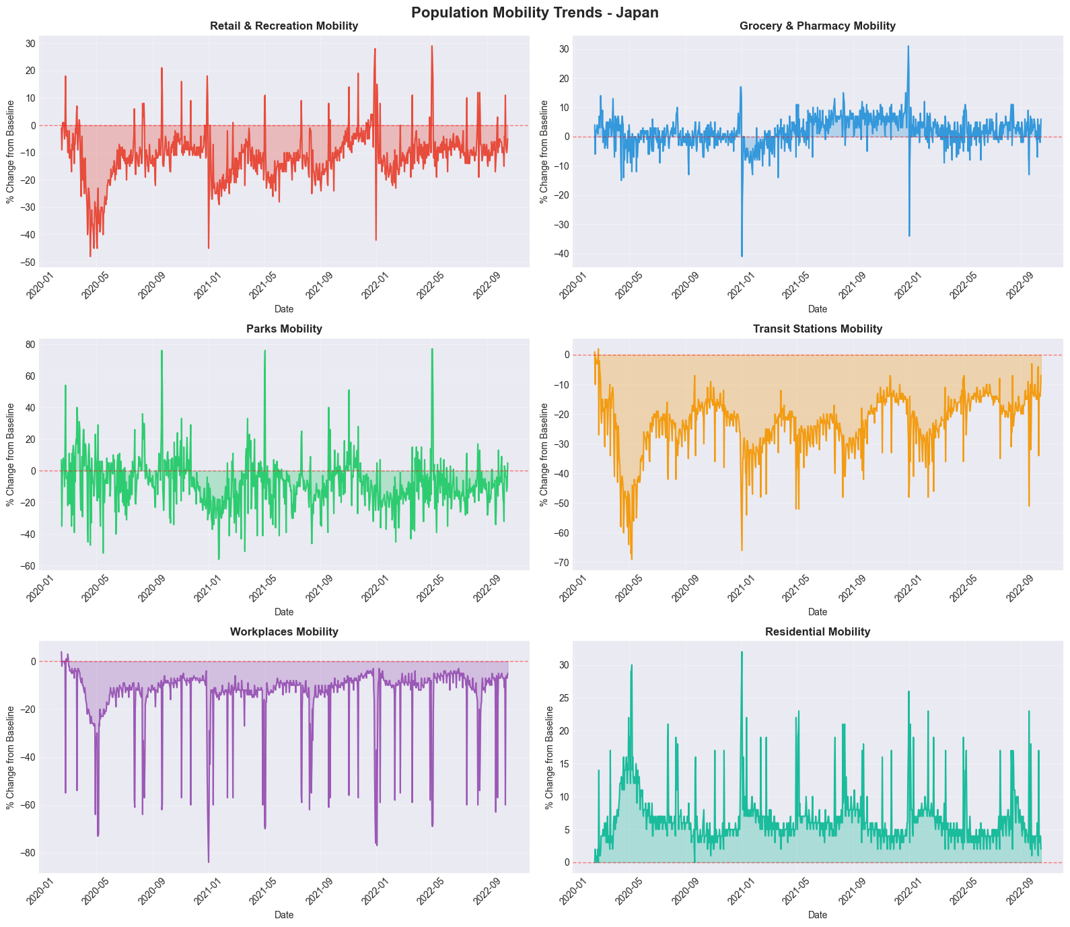
- Policy: stringency_index trajectory over time.
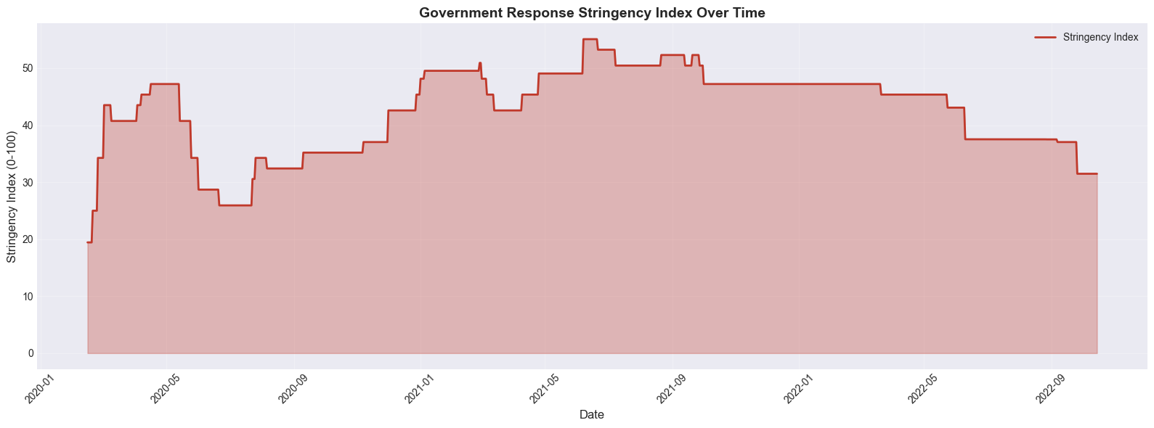

- Distributions and outliers: Histograms and boxplots for key variables; IQR-based anomaly counts computed.
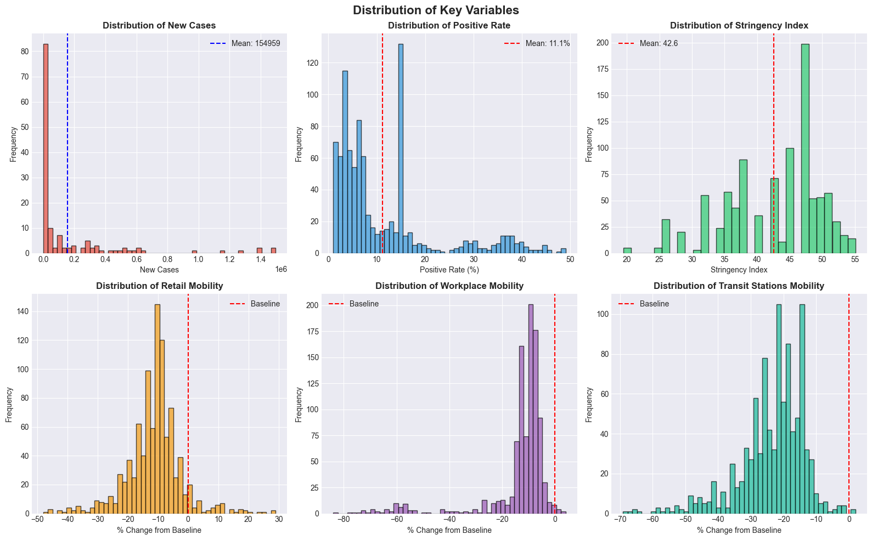
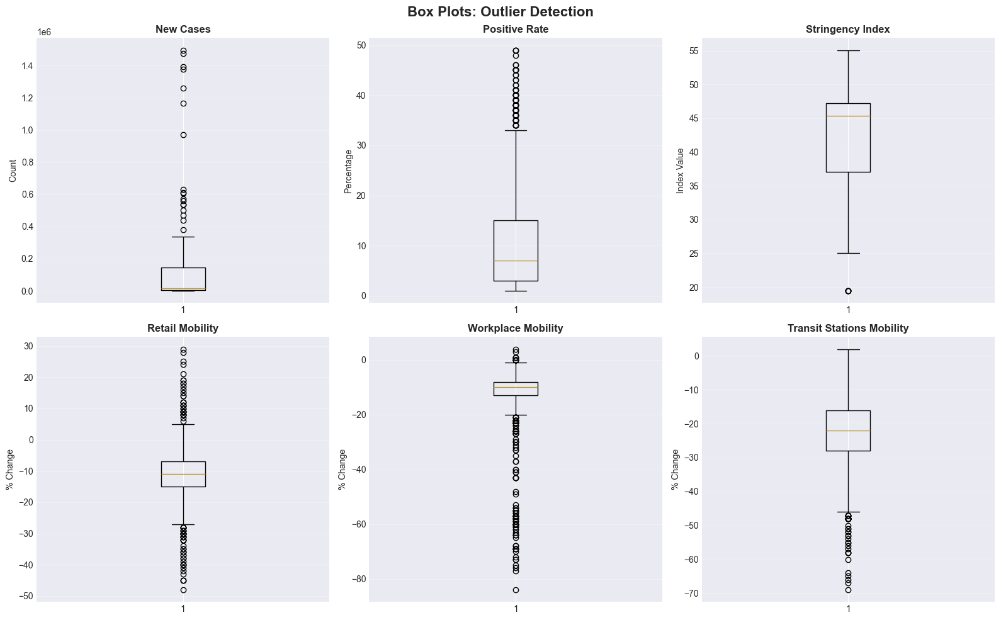

- Correlations: Full correlation matrix; top correlations with new_cases and positive_rate highlighted.
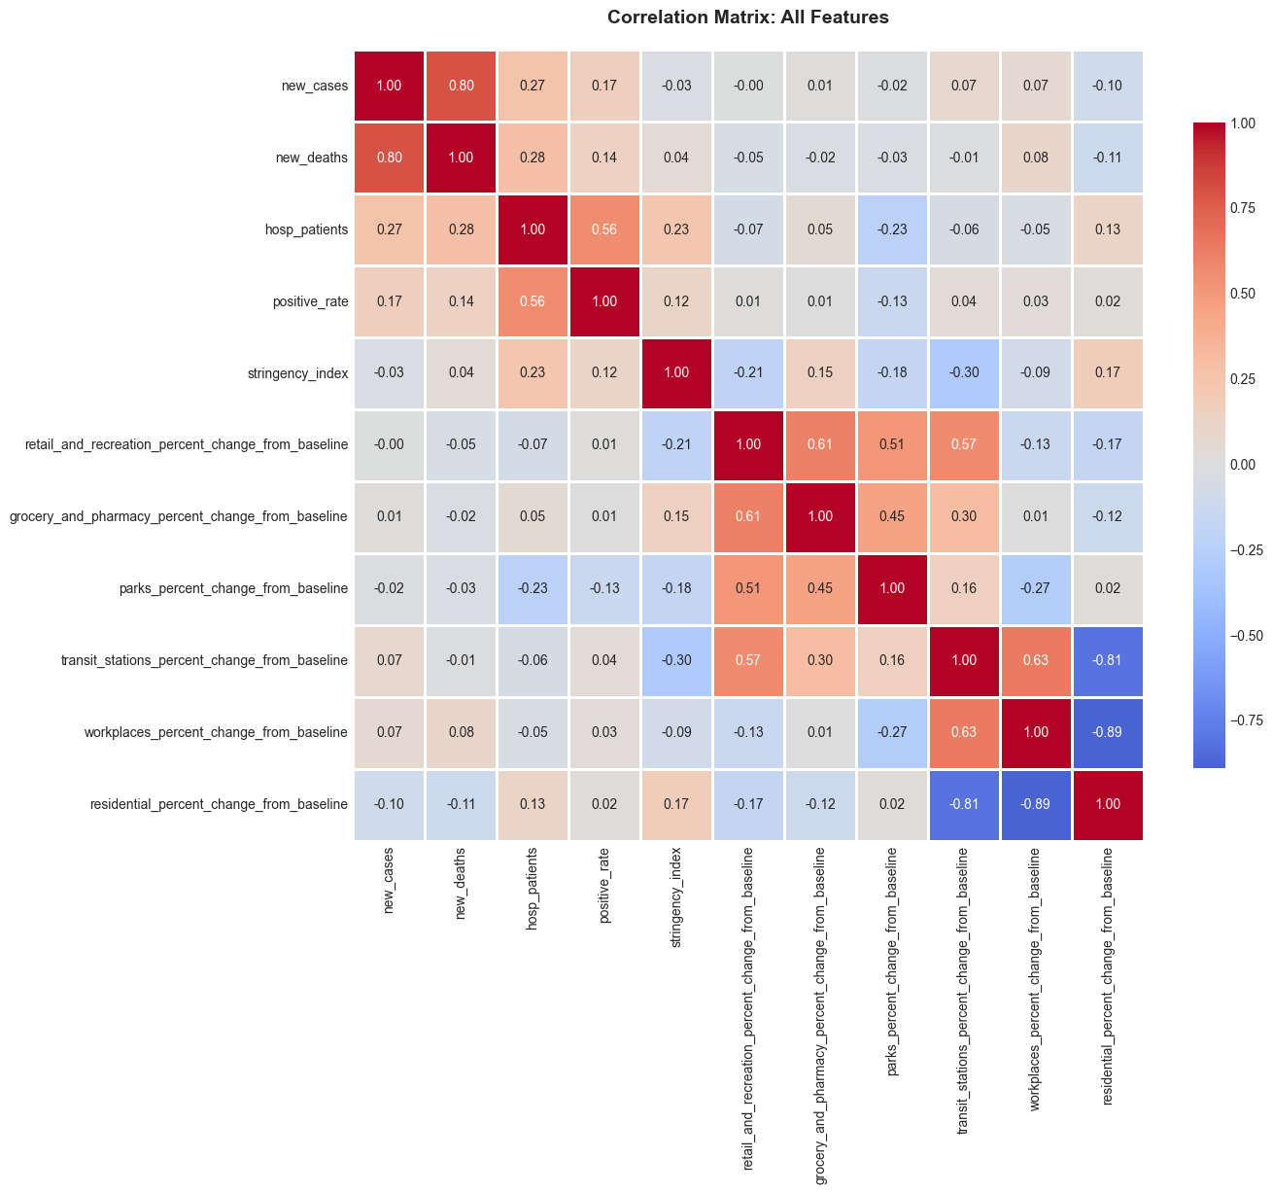
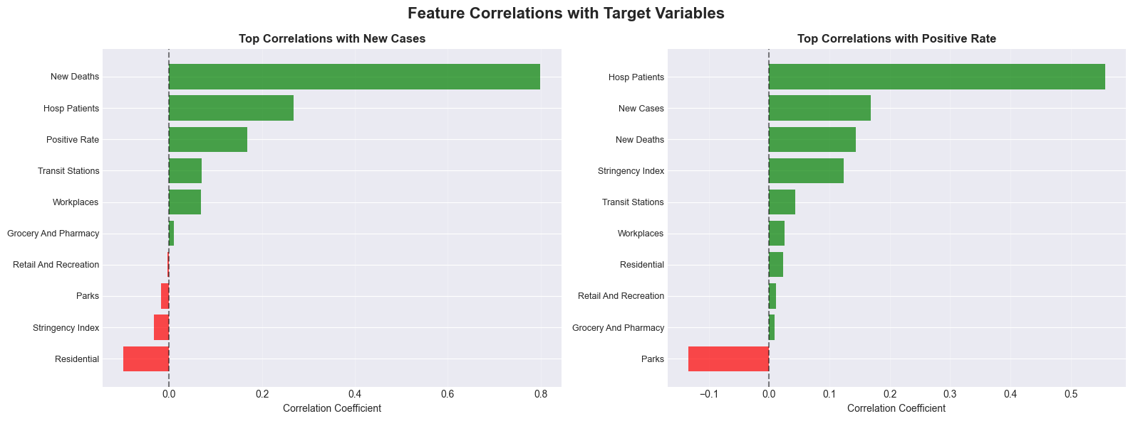

- Lagged relationships:
  - Mobility → New Cases (Lagged) - correlation curves for 0-28 day lags
  - Mobility → Positive Rate (Lagged) - correlation curves for 0-28 day lags
  - Stringency Index → Workplace Mobility (Lagged)
  - New Cases → New Deaths (Lagged)
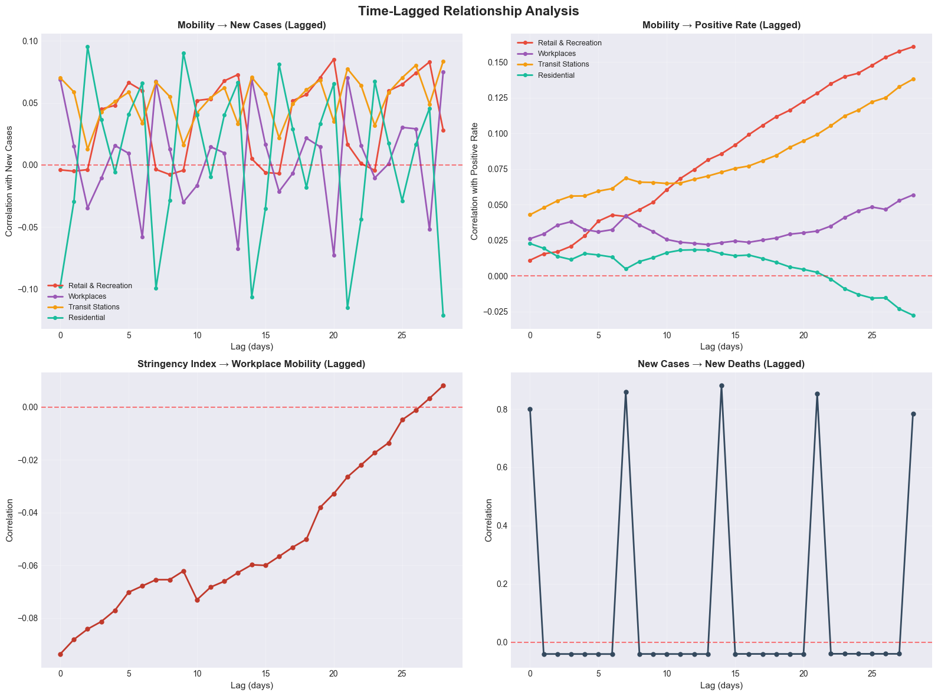

- Seasonality: Monthly and day-of-week patterns; logic for weekly reporting detection with distributed totals for visualization.
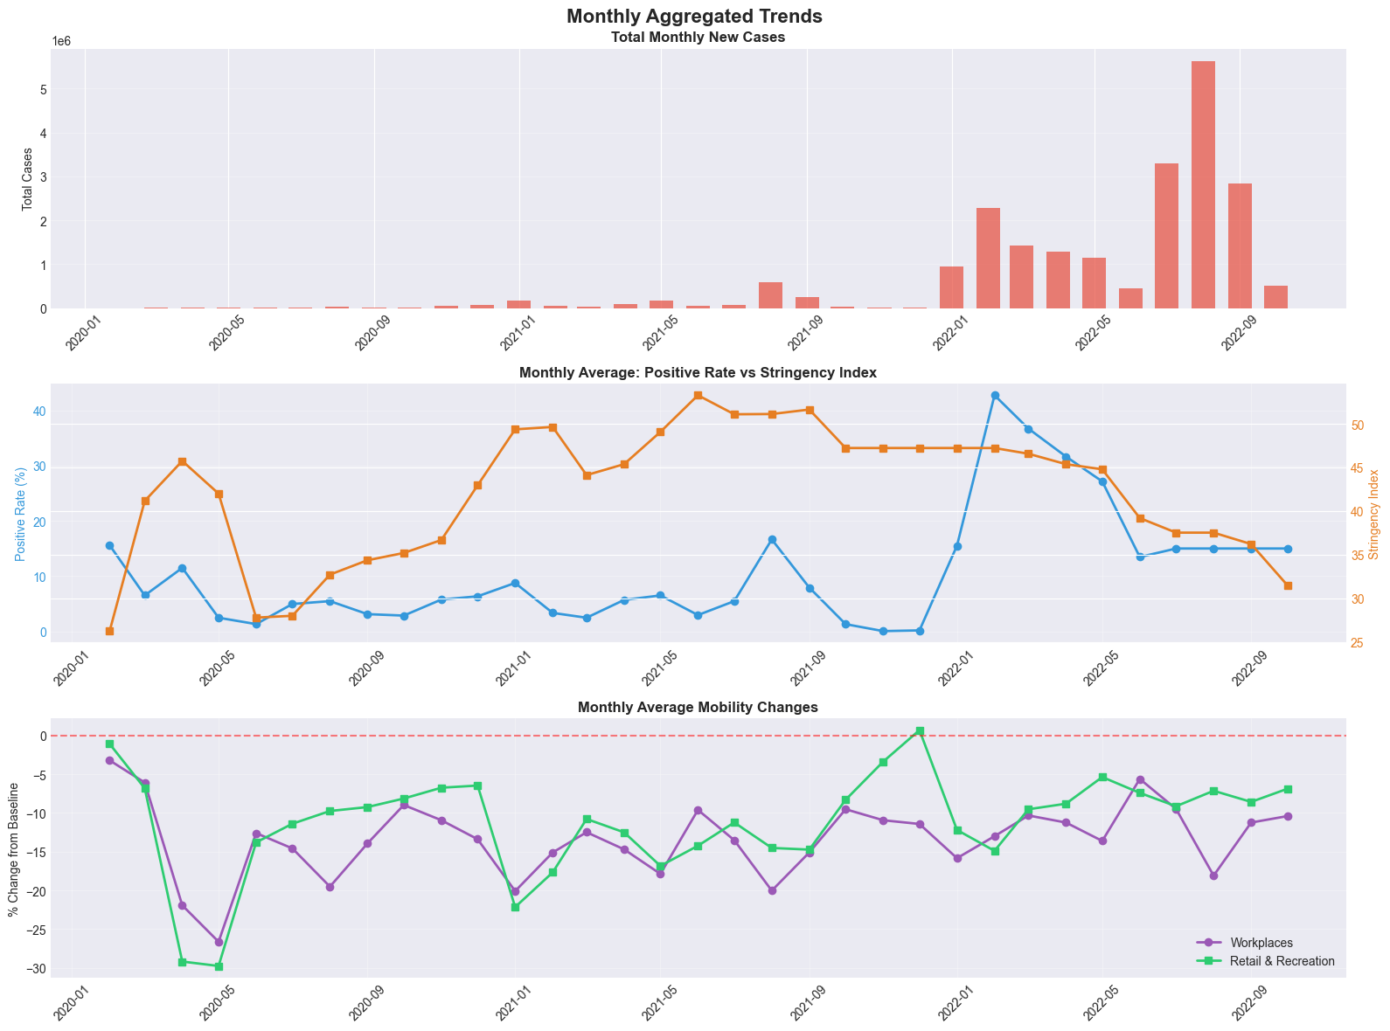
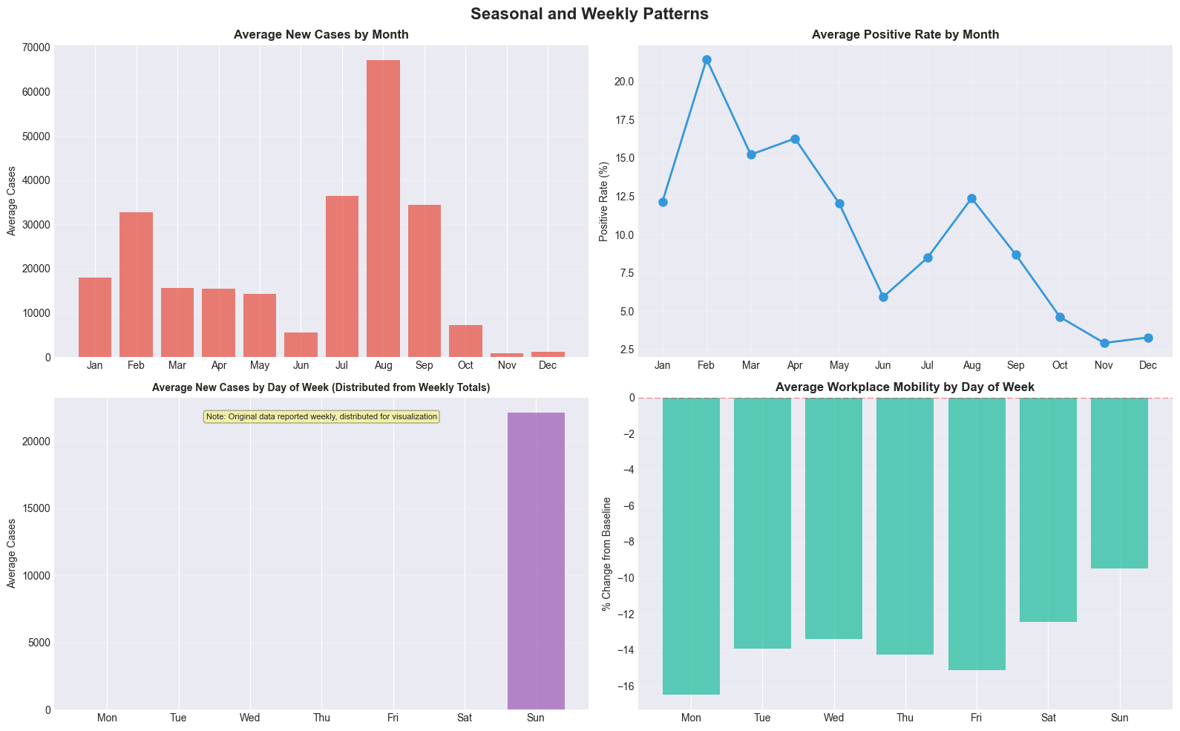

5. Feature Engineering
- Temporal features: year, month, day_of_week, week derived from date for seasonal/cyclical effects.
- Rolling features: 7-day and 14-day rolling averages for new_cases, positive_rate, and workplaces to smooth noise.
- Lagged features (EDA and guidance): 7, 14, 21-day lags recommended for mobility features; extended grid 0–28 tested in EDA for insights.
- Phase features: Policy phase categorical bins from stringency_index to capture regime shifts.
- Rationale: COVID-19 indicators exhibit incubation/reporting delays and seasonality; mobility and policy are leading indicators. Rolling/lags stabilize training targets and improve temporal signal capture.

6. Data Transformation
- Scaling: MinMaxScaler(0,1) applied to target series for LSTM training; sequences created via sliding windows.
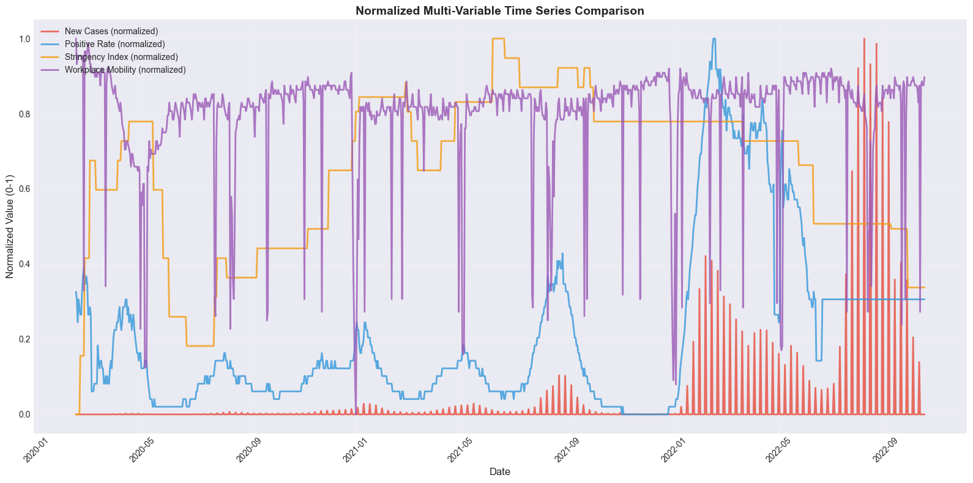
- Encoding: Policy phase represented as categorical bins (EDA). For deep models, keep numeric inputs scaled; categorical phases can be one-hot if included.

Model Exploration

1. Model Selection
- Chosen model: LSTM sequence model for univariate time-series forecasting of `new_cases`.
- Rationale:
  - Captures temporal dependencies and non-linear dynamics.
  - Handles varying lags and seasonality better than simple autoregressive baselines without manual feature engineering.
- Considerations:
  - LSTMs can overfit on short histories; regularization and early stopping used.
  - Scaling required; interpretability lower than linear models.
  - Multivariate inputs (e.g., mobility lags) could further improve performance in future iterations.

2. Model Training
- Data split: 80% train, 20% test (time-ordered split).
- Sequence window: 30 timesteps.
- Architecture: LSTM(64, return_sequences) → Dropout(0.2) → LSTM(64) → Dense(1).
- Optimizer/Loss: Adam (lr=1e-3), MSE loss.
- Callbacks: EarlyStopping(patience=5, restore_best_weights=True); ModelCheckpoint to `models/lstm_best_model.keras`.
- Epochs/Batch: 50 epochs, batch size 32; training stopped early based on validation loss.

3. Model Evaluation
- Metrics (from output/lstm_metrics.json):
  - MAE: 105,887.14
  - RMSE: 167,049.43
  - R²: 0.5972
- Visuals:
  - Training loss curves:
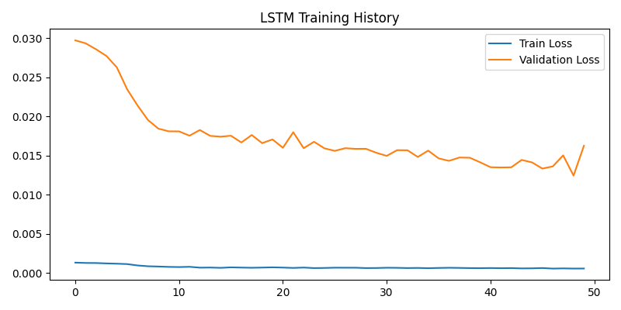
  - Actual vs Predicted:
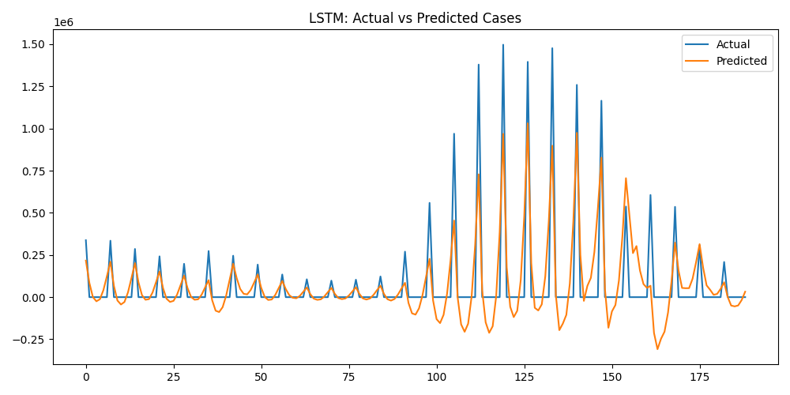

4. Code Implementation
- Data prep / feature engineering: see notebooks/japan-master-data-cleaning.ipynb and notebooks/japan-covid-outbreaks-eda.ipynb.
- LSTM modeling: see notebooks/disease_outbreak_prediction.ipynb.
Minimal runnable snippets:
Data loading and scaling (Python):
import pandas as pd
from sklearn.preprocessing import MinMaxScaler
df = pd.read_csv("data/japan_covid_master_data.csv")
df['date'] = pd.to_datetime(df['date'])
scaler = MinMaxScaler((0, 1))
y = df[['new_cases']].values
y_scaled = scaler.fit_transform(y)
Sequence creation (Python):
import numpy as np
def create_sequences(data, window=30):
X, y = [], []
for i in range(window, len(data)):
X.append(data[i-window:i, 0])
y.append(data[i, 0])
X = np.array(X)
y = np.array(y)
return X.reshape((X.shape[0], X.shape[1], 1)), y
Model definition and training (Python):
from tensorflow.keras.models import Sequential
from tensorflow.keras.layers import LSTM, Dense, Dropout
from tensorflow.keras.callbacks import EarlyStopping
from tensorflow.keras.optimizers import Adam
X, y = create_sequences(y_scaled, window=30)
split = int(len(X) * 0.8)
X_train, X_test = X[:split], X[split:]
y_train, y_test = y[:split], y[split:]
model = Sequential([
LSTM(64, return_sequences=True, input_shape=(X_train.shape[1], 1)),
Dropout(0.2),
LSTM(64),
Dense(1)
])
model.compile(optimizer=Adam(1e-3), loss='mse')
early_stop = EarlyStopping(monitor='val_loss', patience=5, restore_best_weights=True)
history = model.fit(X_train, y_train, validation_data=(X_test, y_test),
epochs=50, batch_size=32, callbacks=[early_stop], verbose=1)
Evaluation and inverse scaling (Python):
from sklearn.metrics import mean_absolute_error, mean_squared_error, r2_score
import math
y_pred = model.predict(X_test)
y_pred_inv = scaler.inverse_transform(y_pred)
y_test_inv = scaler.inverse_transform(y_test.reshape(-1, 1))
mae = mean_absolute_error(y_test_inv, y_pred_inv)
rmse = math.sqrt(mean_squared_error(y_test_inv, y_pred_inv))
r2 = r2_score(y_test_inv, y_pred_inv)
print({"MAE": mae, "RMSE": rmse, "R2": r2})

5. Outputs and Visualizations
- Data: data/japan_covid_master_data.csv
- Model: models/lstm_best_model.keras
- Metrics: output/lstm_metrics.json
- Training history: output/lstm_training_history.png
- Predictions: output/lstm_predictions.png

